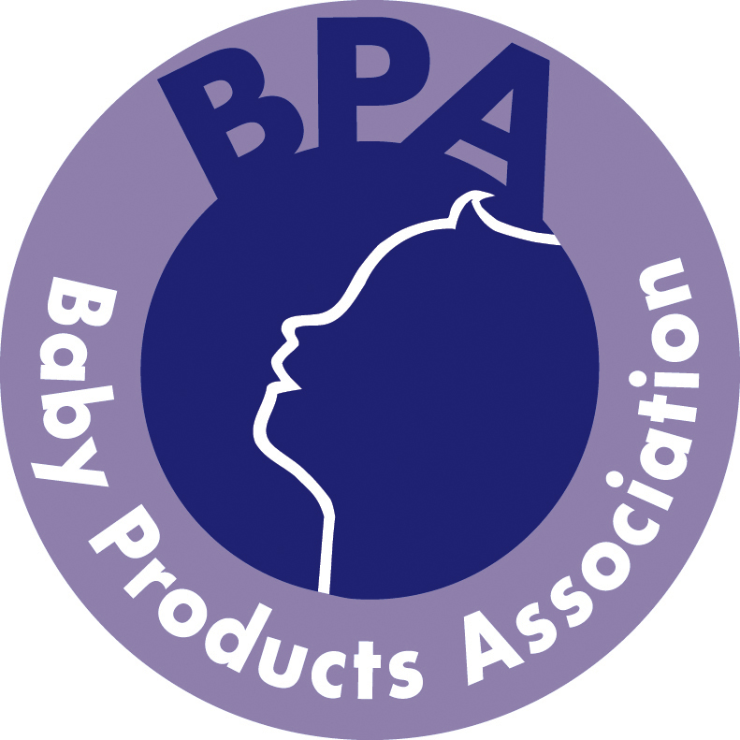

BABY PRODUCTS ASSOCIATION

Nomination Form
TO SERVE ON THE BPA TECHNICAL COMMITTEE FROM 26TH JUNE 2013 TO THE ANNUAL GENERAL MEETING IN JUNE 2014.
To be returned to Julie James, BPA, by post (Grove House, 33 Ashgrove, Steeple Claydon, Bucks MK18 2LW) or by email (julie@b-p-a.org).
I/we nominate the following people/persons to serve on the Technical Committee in the sector indicated*
Sectors explained on page 3.

Candidate’s Name | Company Name | Candidate’s Position | Sector
 |  |  | Seating and body care
 |  |  | Seating and body care
 |  |  | Nursery Furniture,
 |  |  | Nursery Furniture
 |  |  | Wheeled goods
 |  |  | Wheeled goods
 |  |  | Wheeled goods
 |  |  | Child care and protection
 |  |  | Child care and protection
 |  |  | Feeding and drinking
 |  |  | Soft goods
 |  |  | Textiles
 |  |  | Toys and early learning
 |  |  | Child restraints
 |  |  | Test Laboratories
 |  |  | Co-opted
 |  |  | Technical consultant

Please outline the qualifications and experience (including BSI Committees) in relation to technical issues concerning child use & care articles for each candidate(s) you have nominated:

I certify that I have checked that each person nominated is willing to serve on the Technical Committee.

Signed: Position:
Company Date:

* The same candidate may be nominated to serve in more than one sector and/or as a co-opted member.

Sectors

Seating and body care
(Baby walkers, chair mounted seats, highchairs, reclined cradles etc)

Nursery Furniture
(Beds, cots, changing units etc)

Wheeled goods
(Prams, pushchairs, strollers)

Child care and protection
(Safety barriers, harnesses and reins, baby carriers etc)

Feeding and drinking
(Cutlery, bottles, teats and soothers)

Soft goods
(Mattresses, bumpers)

Textiles
(Clothing, bedding, sleep bags)

Toys and early learning

Child restraint systems

Test laboratories

Technical consultant

Co-opted

