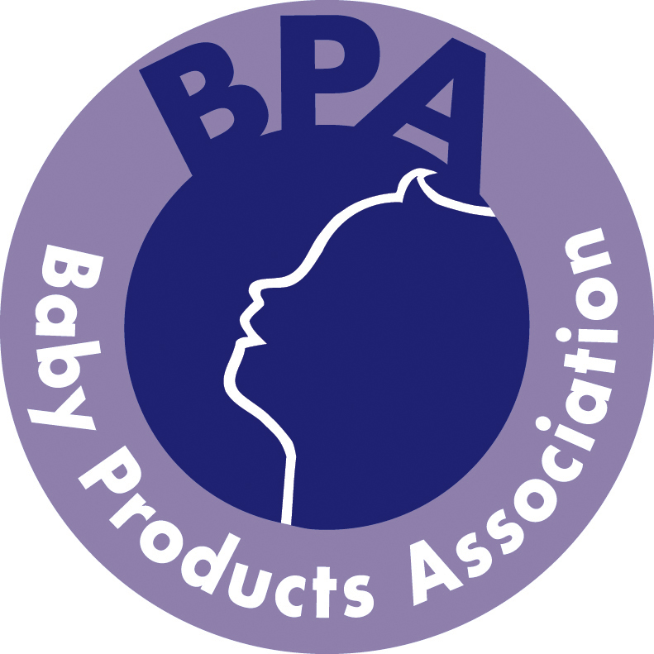

BABY PRODUCTS ASSOCIATION

NOMINATION FORM TO SERVE ON THE BPA EXECUTIVE COMMITTEE UNTIL THE NEXT ANNUAL GENERAL MEETING TO BE HELD IN JUNE 2014.

To be returned to Julie James, BPA, by post or email by 3rd June 2013.

In accordance with the Association’s Rules/Byelaws I/we nominate the following people/persons to serve on the Executive Committee in the Sector indicated.

Candidate’s Name Candidate’s Company Sector

__________________ _________________ Wheeled Goods

__________________ _________________ Wheeled Goods

__________________ _________________ Nursery Furniture

__________________ _________________ Nursery Furniture

__________________ _________________ Components/Accessories

__________________ _________________ Components/Accessories

__________________ _________________ Soft Goods

__________________ _________________ Soft Goods

__________________ _________________ Product Safety

__________________ _________________ Product Safety

Please note that if your candidate’s business represents more than one sector, you may nominate your candidate for all the appropriate sectors.

For each nomination to the Sectors listed above, other than for Co-opted Members, please outline how the candidate represents the Sector concerned:

___________________________________________________________________

___________________________________________________________________

___________________________________________________________________

___________________________________________________________________

I certify that each person nominated is willing to serve on the Committee

Signed: ………………………………......................................... Position: …………………………….

Company: ……………………………………............................. Date: ……………………….............

Postal address: Baby Products Association
Grove House
33 Ashgrove
Steeple Claydon
Bucks
MK18 2LW

Email: julie@b-p-a.org

