MEMBERSHIP REGISTRATION SUBSCRIPTIONS 2023-2024
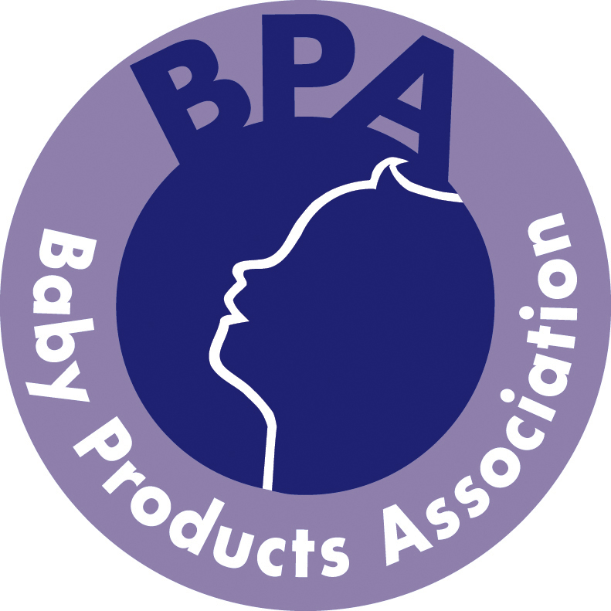

Scale | Turnover Bands  Invoiced Sales | Subscription p.a.+ VAT | Please tick relevant box
Probationary Member | Under £150k AND  Trading for less than 2 yrs | £415
A | Under £1 million | £795
B | Over £1 million under £5 million | £1,900
C | Over £5 million under £10 million | £2,880
D | Over £10 million under £20 million | £4,125
E | Over £20 million under £35 million | £5,760
F | Over £35 million under £50 million | £8,245
G | Over £50 million | £10,975

Please indicate your relevant turnover band by ticking the appropriate box. These rates are valid until October 2024 and then are subject to change.

For calculation of turnover members should note that:

- Sales of Associated companies shall be deemed to be separate entities and as such shall pay a subscription based on the invoiced sales of each company.
- Sales by companies that are subsidiaries of other member companies shall be aggregated with those of the parent company, and the subscription rate shall be calculated by the BPA with reference to the sales of the group as a whole.
- As a general rule the total turnover of the member should be included on this declaration but where a member has invoiced sales that are not related to the nursery industry, for the purpose of calculating turnover for subscription purposes the member should only exclude sales of a product that is not eligible for display at Harrogate International Nursery Fair. *
- Where a member company’s sales are made up of services and not products e.g. test house fees then the member should include all turnover related to baby and nursery products.

* As a guide we would expect sales of the following to be INCLUDED in the declaration: sales of all baby and nursery products, baby related equipment such as prams, pushchairs, buggies, nursery furniture, highchairs, baby walking frames, bedding and safety related items, including barriers, car seats and restraints, clothing, bedding, feeding equipment, gifts for young children and prospective parents, toys, audio and books should be included. Accessories for all the above categories should also be included. Sales of products, components and parts should be included irrespective of source. This list is not exhaustive and members are asked to use their discretion.

ALL INFORMATION SUPPLIED WILL BE TREATED WITH THE STRICTIST CONFIDENCE

I certify that all the products that appertain to the Baby Products industry that are manufactured and/or imported and sold by the company within the United Kingdom conform to the required British and/or European Standards. I declare that the turnover band indicated for our last 12 month period is as indicated above.

Signed
--------------------------------------------------------------------------------------------------------------------------
Name
--------------------------------------------------------------------------------------------------------------------------
Company
--------------------------------------------------------------------------------------------------------------------------
Position
--------------------------------------------------------------------------------------------------------------------------
Date
--------------------------------------------------------------------------------------------------------------------------

