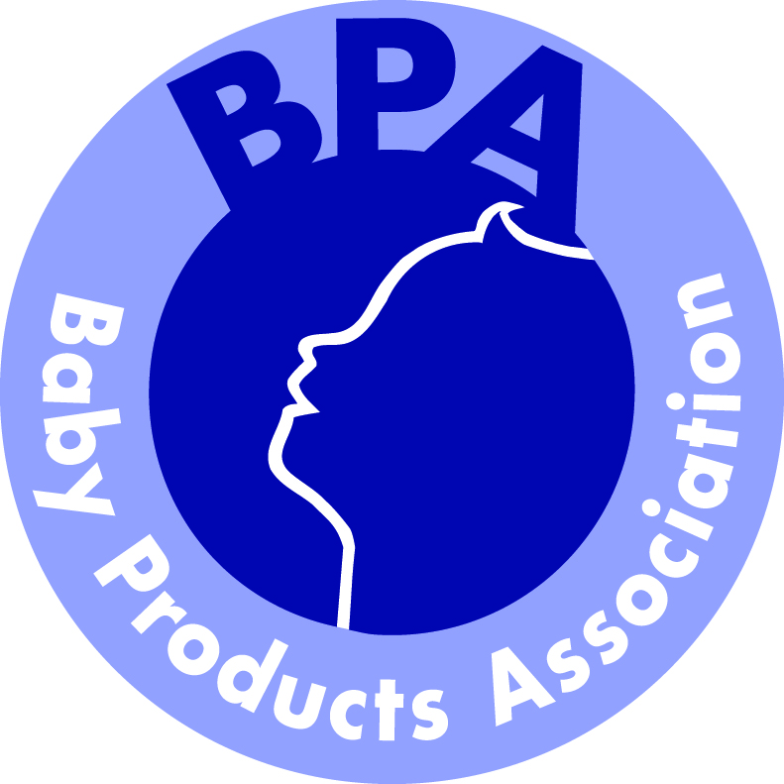
BPA Exporting Conference

Thursday 20th November 2014 – 11.30am to 3.30pm

The Grosvenor House Hotel, 86-90 Park Lane, London W1K 7TN

AGENDA

11.30 – 11.40 Introduction

11.40 – 12.40 Athena Gong, CBME China
Unlock the Doors to China’s Booming Children Baby & Maternity
Products Market

12.40 – 12.50 Jim Shaikh, Yoomi
Yoomi’s first-hand experience exhibiting at CBME Shanghai 2014

12.50 – 13.00 Lily Yang, China-Britain Business Council
Support for UK companies and networks available to tap into demand for UK baby products among Chinese middle classes

13.00 – 13.45 Lunch

13.45 – 14.00 Spencer Mahony, HM Consul and Region Director for UKTI, Washington
What support is available for British companies looking to grow exports in the USA

14.00 – 14.30 Ashley Benjamin and Jennifer Brown, Dehns Patent and Trade Mark Attorneys
Intellectual Property (IP) issues in international trade

14.30 – 15.00 Elaine Lamb, La Playa
The ins and outs of international product liability, insurance and advice to companies looking to expand globally

15.00 – 15.30 BPA
Information about the BPA’s UK Pavilions at CBME Shanghai, Kind und Jugend, Cologne and ABC Kids Expo, Las Vegas

15.30 Close

