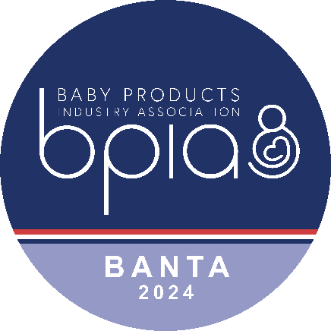

BANTA 2024
Baby Products Industry Association
Baby and Nursery Trade Awards
Entry Form

Organisation/Company Name:

Stand Number:

Product Name:

Product Description (30 words):

Category (please tick):

Baby Essentials Furniture In the Nursery

Baby Health & Wellbeing Clothing & Textiles Toys & Educational

Tech Travel Best New Product

Company Contact Details (Name, Address, Telephone Number and Email):

Image Submitted:

Yes No (to follow)

Signed: Date:

PLEASE ENSURE YOU READ THE RULES ON PAGE 2 BEFORE SUBMITTING YOUR ENTRY
BANTA 2024 Baby and Nursery Trade Awards
Entry Form - page 2

Rules:

- Only one Product Category can be entered per item with the exception of ‘Best New Product’ which can be entered together with ONE other category. However please note that if you enter two categories, you will be charged for two entries.
- Entries must be received by noon on Monday 23rd September 2024. Late entries will not be accepted.
- There is a charge of £85.00 + VAT per entry. Payment must be made within 7 days of submission of our invoice. If payment is not received, your entry will not be accepted.
- Products will be judged prior to the show and you will be notified in advance if your product has been shortlisted.
- The product must be available for final judging at Harrogate International Nursery Fair 2024.
- If your product is shortlisted, please ensure that it is adequately labeled and delivered to the BPIA stand Q12 by 6pm on the final day of build-up (Saturday 11th October). Products will be secured overnight and an announcement will be made asking entrants to collect their products once the judging is complete. You must notify the Association in advance if this is not going to be possible.
- Exhibitors can enter more than one product.
- Only exhibitors at Harrogate International Nursery Fair 2024 can enter.
- Winners will be announced at 4.00pm on Sunday 12th October 2024.
- The judges’ decision will be final.

Notes of Guidance:

Product Categories

The following information is to assist you with choosing the correct category for your product but is for example only and is not exhaustive.

Only one category per product can be entered with the exception of ‘Best New Product’ which can be entered together with ONE other category. Please note that if you enter your product in two categories (i.e. ‘Travel’ and ‘Best New Product’), you will be charged for two entries.

TRAVEL
All groups of car seats, pushchairs, strollers and travel systems
TECH
Electrical equipment such as regular monitors, breathing monitors, sound machines operated from phones, Apps etc.
FURNITURE
Cribs and cots including travel cots, changing units, high chairs
IN THE NURSERY
Baby monitors, nightlights, mobiles, Moses baskets
CLOTHING & TEXTILES
Bedding including mattresses, sleepbags, all baby clothing, muslins and blankets, baby towels and robes
BABY ESSENTIALS
Feeding, weaning and changing products and accessories such as nappies and changing bags, carriers, potties, bottles, cutlery and soothers
BABY HEALTH & WELLBEING
Safety gates, cooker guards, tap guards, harnesses and reins, vitamins, medicine applicators, nail clippers
TOYS & EDUCATIONAL
Products to stimulate and encourage child development such as toys, activity centres, books and games
BEST NEW PRODUCT
Any product launched to the market since 1st January 2024

Images – should be emailed with this application form. Images are required to be at least 10cm high and 300 dpi resolution. All entries require an image – those without will be disqualified.

Prototypes – at the time of final judging, all entries should be available for sale. Prototypes will not be acceptable for final judging.

THE JUDGES’ DECISION IS FINAL. NO CORRESPONDENCE WILL BE ENTERED INTO AFTER THE BANTA ENTRY CLOSING DATE.

Please send completed application forms to: Email: julie@b-p-a.org

Or postal entries: Julie Milne, Baby Products Association, Ael-Y-Bryn, Login, Whitland SA34 0XE

