Application Form 2022

Name:

Address:

Post Code:

Tel no:

Email:

If you are a student of higher education, please state the University/College you are attending, which course you are undertaking and which year the course will be completed.

Name:

Address:

Post Code:

Course Title:

Year of course completion:

Please return this entry form to the Baby Products Association by 12 noon, Friday 26th August 2022.

Award Choice
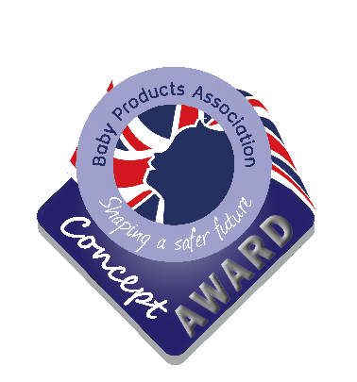

My product is in its early phase of development and I wish to enter it within the Concept Category

Please tick here

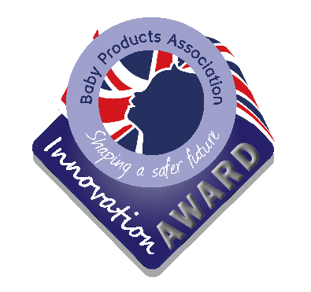

My product is in its final phase of development and I wish to enter it within the Innovation Category

Intellectual Property
Please tick here

The Baby Products Association strongly advises entrants to safeguard and secure the Intellectual Property rights and design rights of their products. Although the Baby Products Association employees and members of the judging panel sign confidentiality agreements, if you succeed as a finalist, you will be asked to showcase your product to the industry and therefore your product will be in the public domain.
A signed confidentiality agreement was sent with this entry form. Please sign and return this with your application. All entries will be treated in the strictest confidence, and will be shown only to the judging panel.
For further information and advice in the first instance, please contact the UK Intellectual Property Office.

UK Intellectual Property Office, Concept House, Cardiff Road, Newport NP10 8QQ Website: www.ipo.gov.uk
Email: enquiries@ipo.gov.uk Telephone: 0845 9500 505 or 00 44 1633 813930

WITHIN THE SPACE PROVIDED BELOW AND ON THE FINAL PAGE, please outline the nature of the product you are entering and include pictures and/or drawings.
After the closing date, a shortlist of candidates will be selected by the judges. These entrants will then be asked to present to the judging panel, providing more comprehensive information about their product. A presentation using Microsoft PowerPoint will be possible at this stage, if desired. This will take place at a date to be confirmed and from here, the finalists will be chosen. The finalists will be asked to exhibit their product at one of the industry’s premier trade events with which the Baby Products Association partner; Harrogate International Nursery Fair which will be held from 16th – 18th October 2022. This is an incredible opportunity for you to showcase your product design and the experience alone is considered a worthy prize. Please ensure you are available to attend this 3-day event as this is a necessary requirement for entry to the award programme. The winner for each category will be announced at the end of the first day of the show.
Please address any queries about the competition to Julie Milne at the Baby Products Association: Tel: 0845 456 9570: Email: julie@b-p-a.org.
For more information about the trade event, visit www.nurseryfair.com

Product Information
Please outline the nature of the product you are designing, its purpose and the age range for which it is intended. Please refer to the guidance notes which were sent to you with this entry form. We recognise that your original concept may change as you develop your ideas. All entries will be treated in the strictest confidence, and will be shown only to the judging panel.

Continue on a separate sheet if necessary or preferred

Signed

Date _

Please submit your entry by 12 noon on Tuesday 16th August 2022 to:

Julie Milne, Baby Products Association, Grove House, 33 Ashgrove, Steeple Claydon, Bucks MK18 2LW

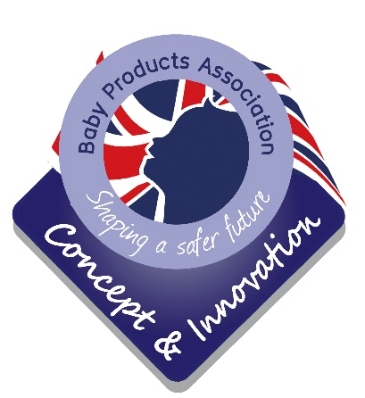

Guidance notes for applicants
About the Baby Products Association
The Baby Products Association was established in 1945, with the objective of promoting the baby and nursery products sector in both the UK and Europe. It is now the voice of the baby and nursery products industry. Today, it plays an active role in the development of product standards and provides an umbrella of support and specialist services to its membership.

What are the Association’s Concept & Innovation Awards?
The Baby Products Association actively encourages new product development and innovation in its industry and, for a number of years, has championed visions of new design through the Concept Award. The award is presented at our partner premier nursery trade event; Harrogate International Nursery Fair in the presence of key members of the industry.
In previous years, we have seen new inventions launched successfully onto the UK market via the Concept Award. The Baby Products Association believes it is important that the industry has a vibrant and proactive outlook on innovation and is determined that new ideas continue to come through.
In 2009 the award programme evolved slightly; the core objective has always been to recognise new concepts and now the programme has grown to recognise designs in their infancy and those closer to the finished article. Under the umbrella of Concept & Innovation, we now have two awards; the Concept Award, acknowledging products still in their early visionary phase and Innovation acknowledging products developed to a potential production stage.

What are we looking for?
Products should be within the following scope:

All baby and nursery products, baby related equipment such as prams, pushchairs, buggies, nursery furniture, highchairs, safety related items including barriers, car sets and restraints, clothing, bedding, alarms, gifts for young children and prospective parents, toys, audio and books should be included. Accessories for all the above categories should also be included.
Please note, this award programme only applies to products in development and not articles available for sale as at 1st October 2022.

Applicants are asked to consider the following aspects when considering their application:

- Use of environmentally friendly and sustainable goods
- Safety awareness and reduction of accidents
- Current and future requirements and demands on parents in everyday living The issues you need to think about at this stage are:
- What is the purpose of the product?
- What age and weight range is it suitable for?
- Is it novel? What would be its unique selling point(s)?
- What leads you to believe that the product will sell?
- How much will it cost to make the economic batch quantity and what will be the retail price of the product?
- Is it safe? Which safety standard(s) are relevant to your product and is it likely to meet these standards?
- What information should be included in the instructions for use on the packaging, on the product itself and at the point of sale?

For products where there are no relevant product safety standards applicable, it may be necessary to consult PD CEN/TR 13387 – Child Care & Use Articles – General & Common Safety Guidelines (Parts 1-5) (Correct at time of going to print but may be updated before the 2022 show)

Interested?
If you would like to enter either of these awards, please complete the attached entry form, clearly stating which award programme you are entering (Concept or Innovation). When submitting your application, please also include engineering drawings and/or photographs or sketches of your product. Applications should be returned no later than 12 noon, 16th August 2022 to:

Julie James, Baby Products Association, Grove House, 33 Ashgrove, Steeple Claydon, Buckinghamshire MK18 2LW
A shortlist of candidates will be asked to formally present their products to the judging panel, providing further information about the product and where appropriate, demonstrate a prototype. It will be possible for these selected entrants to use a Powerpoint presentation if desired. From this meeting, the finalists will be chosen.

The Prize
The finalists will be invited to attend Harrogate International Nursery Fair in conjunction with the Baby Products Association which will be held from 16th – 18th October 2022 as an exhibitor, showcasing their products to the nursery industry. Finalists will be required to provide a prototype or professional graphic drawings for the exhibition stand. The winners of both awards will be announced at the end of the first day of the show. An additional prize is offered by the sponsors and will be announced nearer the time.

Services which may be of interest

- Finch Group – Finch Group, established in 1971, is an Insurance Broker with a dedicated service ethic. We are part of Ethos Broking, giving us an unparalleled support system.
Insurance is a specialist area; regulated by the Financial Conduct Authority in the UK. The Baby Products Association are therefore not permitted to give you any advice on insurance, nor recommend insurers. However, Finch Group have put together a comprehensive package of insurance covers, specifically designed for this association. Please be assured that the Baby Products Association does not benefit from this arrangement – except to provide assistance to its members.

- 3volution – is a Leeds-based integrated commercial law firm focussed on the legal needs of both businesses and the people that own and run them. It can offer specialist advice on company law, employment issues, agents, regulatory defence, commercial property, intellectual property, dispute resolution, insolvency, franchising and corporate finance.

- Quest – Advice line covering HR, employment, legal, health & safety, tax and VAT with a website featuring a comprehensive library of employment, legal and health & safety documents provided free of charge and without restriction to members.

- The Baby Products Association is often asked to recommend test houses to its members and is delighted to announce its partnership with Intertek which has over 30 years of experience in testing toys and childcare articles offering Total Quality Assurance.
Intertek goes beyond regulatory testing to provide research and development services that incorporate real-life child observation and risk analysis to assess, identify and predict potential hazards in toys and children’s products at all stages of development and production.
With this partnership, Baby Products Association members will benefit from a generous discount on testing services.
- Touchfinder – specialists in bespoke software solutions.

If you would like contact details of any of the above companies, please call the Baby Products Association on 0845 456 9570 or email julie@b-p-a.org.

