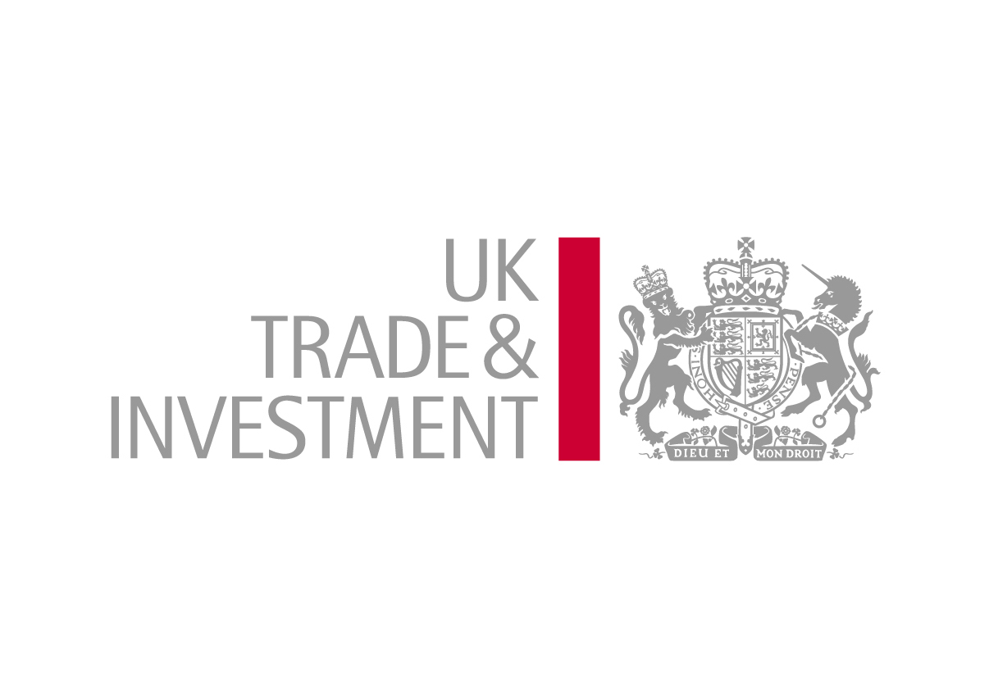

UKTI TRADESHOW ACCESS PROGRAMME SUPPORT SCHEME FOR OVERSEAS EXHIBITIONS
TERMS AND CONDITIONS FOR EXHIBITORS
2012-13

BACKGROUND

UK Trade & Investment (UKTI) will, at its discretion, provide support for businesses taking part in overseas exhibitions between 1 April 2012 and 31 March 2013. For the purposes of these terms and conditions overseas exhibitions are defined as:

- involving the display of products and services on exhibition stands or areas by businesses and other organisations with the objective of attracting commercial interest in those products and services; and

- taking place outside the United Kingdom and being international in terms of representation i.e. involving exhibitors from more than one country; and

- dealing with trade representatives rather than the public; and

- using stand space or area that is designed for the purpose of an exhibition and not for any additional use not specifically connected to exhibiting.

Alternatively an eligible event can be:

- an overseas commercial conference where the business has paid for the opportunity to promote its goods or services to a trade audience.

The objective of exhibition support is to help, primarily, newly exporting SMEs to learn how to use exhibitions as a key tool in their trade development plans. The support is intended to work most efficiently as part of a development programme for eligible businesses which Accredited Trade Organisations (ATOs) and UKTI’s regional network can help to facilitate.

A central principle of this, and all UKTI grant, is that it should make something happen that would not happen otherwise. Each eligible business is entitled to exhibit with grant support on a total of six occasions counted from 1 April 2009 and covering at least two markets. For participants who have had no TAP grants prior to 1 April 2012 at least three of these six participations must be in the emerging and high growth markets listed below.

Brazil  China  Colombia  Egypt  India  Indonesia  Malaysia | Mexico  Qatar  Russia  Saudi Arabia  Singapore  South Africa  South Korea | Taiwan  Thailand  Turkey  UAE  Vietnam  Hong Kong

Independent (Solo) participations are only available for events in the high growth and emerging markets or for businesses already on UKTI’s Gateway to Global Growth or Passport to Export programmes. Solo participants must not take any more than one of these participations in any one financial year. The six grants amount to a lifetime limit and cannot be renewed.

ATOs will help those businesses approved for grant to participate effectively in an exhibition and International Trade Teams in UKTI’s regional network will also help those businesses, where appropriate. Participating businesses are expected to take up any offers of non-chargeable assistance made in this context.

The relevant ATOs will be expected to provide enhancements for the group presence to make it more effective and will be remunerated for this by UKTI.

If ATOs charge supported participants a service or management fee in connection with their participation, the services to be covered in return for the charge must be fully explained to participants at the time of recruitment. Such ATO charges should relate to costs wholly distinct from their administration of the business’s UKTI grant application and from the UKTI funded enhanced services.

It is expected that participants will make full use of the services and advice provided by or via the ATO. However, participants will also have the opportunity to apply for UKTI support to attend any exhibition independently under solo arrangements. This would normally be where there is no ATO led group. Where an ATO is leading a supported group at an event, the solo route can only be taken with the explicit direction of the relevant International Trade Team. In these cases the International Trade Team must confirm on the participant’s application form that the solo route has been taken because the ATO was unable, through their own arrangements, to offer a stand space or exhibition area that was reasonably suitable for the participant’s stated needs or was unable or unwilling to accept the business into their group under any other arrangements.

1 Eligibility to apply for grant

1.1 To be eligible for grant participants must meet the following criteria.

a) A participant must be a UK* based business or organisation that is either actively investigating export opportunities or is already involved in exporting from the UK. If requested, participants must provide UKTI with supporting documents proving that they comply with this requirement.
(*Excluding businesses/organisations based in the Isle of Man or the Channel Islands unless UK registered.)

b) A participant must be a small or medium sized enterprise as defined below or a UK university or UK Government funded centre of higher or further learning, or a UK Government-funded research organisation;

c) A participant must be a new exporter as defined below or have exported for no more than 10 years;

d) Any grant a participant applies for does not result in them breaching the de minimis State Aid limit of €200,000 over any rolling three year period. (These grants are classed as de minimis State Aid by the Commission of the European Communities and all applicants for grant must ensure that they do not exceed the €200,000 limit. EU Regulation 69/2001 on the application of Articles 87 and 88 of the EC Treaty to De Minimis aid refers.) The only exception to de minimis coverage relates to activities linked to the production, processing and marketing of certain agricultural goods as listed under Annex I of the consolidated version of the Treaty establishing the European Community (consolidated version 1997). TAP grants to relevant businesses covered by Annex 1 must fall within an overall ceiling of support that the European Commission have agreed to cover this specific area. Applicants must take the advice of their local International Trade Team and, if advised to do so, should complete the alternative version of the TAP application form designed to cover businesses in this category.

e) A participant must not receive any other contributions from public funds towards TAP eligible costs in relation to participation at the event named in Section 1 of the Exhibitor Grant Application Form.

f) A participant must not have been fully committed to attend the event prior to seeking UKTI grant.

g) A participant must demonstrate that they:

- are selling products or services originating substantially in the UK; or
- are adding significant value to a product or service of non-UK origin; or
- are enhancing their competitiveness and providing tangible economic benefit to the UK from this trade development activity.

h) Since 1 April 2009 a participant must not have received, been offered or have a pending application for more than five grants under these terms and conditions prior to the grant currently being applied for. Additionally, within this total of six grants overall, Solo participants must not have received, been offered or have a pending application for any other solo support for an event in the same financial year as the one being applied for. For participants who have not had a TAP grant prior to 1 April 2012, at least three of the six grants must be taken in the high growth and emerging markets listed in the background section above.

i) A participant must take up any non-chargeable offers of assistance made by the ATO or the UKTI regional network that are intended to be complementary to the offer of trade fair support.

1.2 Participants will be ineligible if they do not own the brand they are selling and the brand owner either already exports to the market concerned or withholds permission to export to that market.

1.3 In operating these terms and conditions the following definitions apply.

Definition for Small and Medium Sized Enterprise
a) Has less than 250 employees.

b) Has an annual turnover not exceeding € 50m, or an annual balance sheet total not exceeding € 43m.

c) Is independent, i.e. not more than 25 % of its capital or voting rights are owned by one enterprise, or jointly by several enterprises, which fail to meet any of the above points at a and b, although this threshold may be exceeded in the following two cases:

(i) if the business is held by public investment corporations, venture capital companies or institutional investors, provided no control is exercised either individually or jointly over it;

(ii) if the capital is spread in such a way that it is not possible to determine by whom it is held and the business can legitimately declare that 25% or more of it is not owned by one enterprise or jointly by several enterprises falling outside the definition of a SME.

Definition for New Exporter
During the past 12 months less than 10% of turnover resulted from proactive exports (i.e. sales to new overseas customers that have been actively identified by the business) and no more than 25% of turnover resulted from a combination of proactive and reactive exports. (Reactive exports would normally result from unplanned approaches from potential overseas customers and from UK-based third parties, or from overseas responses to UK-focused web sites).

1.4 The requirement to be a new exporter or to have been an exporter for less than ten years will be waived where the applicant has not attended the previous edition of the event.

1.5 UKTI is committed to making every effort to assist people with disabilities or long term health conditions to undertake business overseas. Applicants should raise any concerns in this respect directly with their ATO or, in the case of solo support, directly with the TAP team. Any such issues should be raised at least three months prior to the event start date.

1.6 Payment of grant is discretionary and shall be the limit of UKTI’s liability to the participant for the exhibition named at Section 1 of the Exhibitor Grant Application Form.

2 Requirements for Eligible Participants

2.1 Participants must also comply with all of the following conditions.

a) Participants must correctly complete a TAP Exhibitor Grant Application Form and submit it via their local UKTI representative (at the UKTI International Trade Team) or via the ATO that is organising a group at the relevant event (normally this would depend on whoever supplied the form), no later than eight weeks before the event start date.

b) Participants must only promote at the event the business, trading and brand names detailed on their application form.

c) Where any non-UK goods or services are to be promoted participants are able to clearly explain the associated economic benefits to the UK, if required. They must also present themselves at the exhibition as a business/organisation involved in exporting from the UK.

d) Participants must ensure that their exhibition stand or space is manned by at least one dedicated representative for the duration of the exhibition. In the case of exhibitions lasting more than seven days, they may leave after spending seven days at the exhibition but only if they have notified the ATO or International Trade Team in writing prior to the opening date.

e) If there is only one individual representing both the participant and any other eligible exhibitor(s), then grant can only be claimed in respect of one of the businesses being represented.

f) UKTI will have no responsibility for insuring any risks associated with taking part in the exhibition. UKTI will not be liable for the consequences of any such risks or any costs incurred. Any insurance required by the participant will be the responsibility of the participant.

g) All participants must submit a completed UKTI Exhibitor Questionnaire to UKTI prior to any claim for grant being submitted to UKTI. The final deadline for return of completed questionnaires is one month after the closing date of the event. The questionnaires for completion can be found on the UKTI web site.

h) Participants must register for free full UK Business access on UKTI's website prior to submitting their application.

2.2 Applicants should not assume TAP support has been agreed unless they have received an “offer letter” from the TAP Team following their application for Solo support or, in the case of ATO led groups, the TAP Team have confirmed applicant eligibility with the ATO. UKTI reserves the right to reject any application that it considers for any reason to be unsuitable.

3 Claiming Grant

3.1 The ATO will claim grant on behalf of the participant generally at a rate of £1,000, £1,400 or £1,800. The choice of which of these levels of grant will be offered for a particular event will have been agreed by the ATO with UKTI at the beginning of the programme year and will reflect the overall TAP funding available for that sector. In exceptional cases UKTI’s TAP Team will have agreed with ATOs that different levels of grant to those above can be offered for an event, with the intention of allowing a greater incentive for new exporters. TAP grant is paid on the basis of matching funds i.e. businesses must make an equivalent contribution to the grant being offered. Therefore, in order to be included in the claim, participants must be able to provide the ATO with evidence that they have paid a minimum equivalent to twice the grant being claimed on their behalf on eligible costs directly related to their attendance at the event. If the ATO does not already have this evidence the participant must provide this to the ATO no later than one month following the end of the exhibition.

3.2 Where participants have exhibited independently of the ATO led group (the solo route) they can claim at a flat rate of £1,000 using the standard TAP solo claim form provided by the UKTI TAP Team and submitting it via the relevant International Trade Team in time for it to arrive with the TAP Team no later than two months following the end of the exhibition. If requested, they must provide UKTI with evidence that they have paid a minimum of twice the grant amount on eligible costs directly related to their attendance at the exhibition for which they are claiming grant (see Section 3.3). Such evidence must be made available for UKTI or its representatives within 15 working days of its request.

3.3 Direct costs can be in any of the following categories.

Exhibition space costs. This is the actual amount paid by the participant, or the ATO on the participant’s behalf, to the commercial organiser of the exhibition* for space at the exhibition venue and any other mandatory charges (e.g. registration fees, catalogue entry charges). These charges will normally be no higher than the rates published by the commercial organiser of the exhibition.
Stand costs. This is the actual amount paid by the participant, or the ATO on the participant’s behalf, to the commercial organiser of the exhibition, or to any third party supplier(s) for invoiced costs directly related to:

- stand design;

- physical stand costs, including shell scheme (or equivalent);

- labour costs in relation to physical construction of stand;

- heating;

- power supply;

- carpets;

- furniture hire;

- cleaning;

- internet/phone connection and rental (excluding call charges);

- display aids and graphics, but excluding any products/samples unless they are part of the stand construction;

- security;

- freight costs for stand and stand display items;

- excess baggage charges for stand and stand display items;

- car/van hire and other associated travel costs e.g. fuel (If this option is used, the participant must be able to present a justifiable case, including cost benefits)

Conference Costs. This is the amount charged by the conference organiser for attendance or speaking. It can also include the cost of preparing and transporting literature or display items specifically for the conference.

NB. Recoverable local taxes, including VAT, and insurance costs of any kind will not be considered as part of the total of eligible costs.

*The commercial organiser of an exhibition is the organisation responsible for the commercial arrangements for the whole exhibition. An organisation making a block booking at an exhibition for a UK group, or booking space or stand facilities for individual companies, is not the commercial organiser of the event.

3.4 Once the ATO has claimed grant on behalf of participants the ATO will be responsible for distributing grant to participants within three weeks of the ATO’s receipt of the participant grant.

3.5 The participant may arrange with the ATO for any amount owed to them, solely related to the exhibition, named at Section 1 of the Exhibitor Grant Application Form, to be deducted from the grant. The ATO is not allowed to pay any part of a participant’s grant to a third party and must not have charged the participant for anything other than costs directly related to the business’s supported participation at the event.

3.6 UKTI reserves the right to provide the Commission of the European Communities, or any other organisation which needs the information as part of the process of Government, with information about any grants paid to the participant. UKTI also reserves the right to publish these details without seeking any additional approval from the participant.

4 Non Payment of Grant

4.1 UKTI reserves the right to withhold any or all of the grant, or require part or full repayment of any grant already paid, if at the time of making the application or at any time prior to the start of the event the participant:

a) has ceased or ceases trading;

b) is in or goes into liquidation, administration, receivership, bankruptcy or equivalent procedures in Scotland;

c) is or becomes the subject of a proposal for a winding up order or any other insolvency procedure including individual voluntary arrangement;

d) is or becomes indebted to any Government department.

4.2 UKTI also reserves the right to withhold any or all of the grant, or require part or full repayment of any grant already paid, if the participant:

a) fails to comply with any of these Terms & Conditions;

b) provides false or inaccurate information on the Exhibitor Grant Application Form;

c) causes embarrassment to Her Majesty’s Government, the host nation or other exhibitors in the group, for example by displays of inappropriate or offensive literature, by inappropriate or offensive behaviour, or by the display of products or services of an unacceptably low quality or of an inappropriate or offensive nature. (The final decision on acceptability will rest with UKTI, taking into account the nature of the product, the sensitivities of the host nation and others in the group).

If any of the above circumstances arise, the business may also be excluded from future involvement in this and/or any scheme operated by UKTI.

4.3 UKTI may vary or withhold any or all payments made and / or may require repayment of grant already paid, together with interest from the date of payment, if UKTI is required to do so as a result of a decision by the European Commission or as a result of any obligation arising under Community Law.

With professional advisers across 96 international markets, UK Trade & Investment is the government department that helps UK-based companies succeed in the global economy and assists overseas companies in bringing their high quality investment to the UK.

For further information please visit www.ukti.gov.uk

SME definition met ?

yes
no
Is business a UK University or UK publicly funded centre of higher or further learning or UK publicly funded research organisation?

New exporter definition met or have been exporting for less than 10 years?
no
yes

Not eligible
no
yes

Did you exhibit at the previous edition of the exhibition?
no
Had less than 6 TAP grants since 1-4-2009?

yes
no

yes
New to TAP at 1-4-2012 and had 3 or more grants outside the high growth or emerging markets since 1-4-2012?

Not eligible

no
yes

Business should progress with their application assuming they can comply with the rest of the TAP terms & conditions

Definition for Small and Medium Sized Enterprise
Has less than 250 employees.

Has an annual turnover not exceeding € 50m, or an annual balance sheet total not exceeding € 43m.

Is independent, i.e. not more than 25 % of its capital or voting rights are owned by one enterprise, or jointly by several enterprises, which fail to meet any of the above points at a and b, although this threshold may be exceeded in the following two cases:

(i) if the business is held by public investment corporations, venture capital companies or institutional investors, provided no control is exercised either individually or jointly over it;

(ii) if the capital is spread in such a way that it is not possible to determine by whom it is held and the business can legitimately declare that 25% or more of it is not owned by one enterprise or jointly by several enterprises falling outside the definition of a SME.

Definition for New Exporter
During the past 12 months less than 10% of turnover resulted from proactive exports (i.e. sales to new overseas customers that have been actively identified by the business) and no more than 25% of turnover resulted from a combination of proactive and reactive exports. (Reactive exports would normally result from unplanned approaches from potential overseas customers and from UK-based third parties, or from overseas responses to UK-focused web sites).

High Growth & Emerging Markets
Brazil  China  Colombia  Egypt  India  Indonesia  Malaysia | Mexico  Qatar  Russia  Saudi Arabia  Singapore  South Africa  South Korea | Taiwan  Thailand  Turkey  UAE  Vietnam  Hong Kong

